



Spring Into Possibilities – Jumper Show
May 2nd-3rd,2026
Closing: April 25th, 2026

Show Manager: Heidi Pratt
Office: Helen Van Hemert
Judge: tbd
Paramedic/First Aid: Jessica McMorran
Course Designer: Jill Neufeld Fuselli / Heidi Pratt
$35 Office Fee

$15 Paramedic Fee

Ribbons to 6th with fun prizes
Goodies for the rider and cookies for the horse for all clear rounds
Prizes for Champion and Reserve
Old As Dirst Division is Back!!

Poles & Petals - Hunter Show
May 9th-10th,2026
Closing: May 2nd, 2026

Show Manager: Heidi Pratt
Office: Helen Van Hemert
Judge: tbd
Paramedic/First Aid: Jessica McMorran
Course Designer: Jill Neufeld Fuselli / Heidi Pratt
$35 Office Fee

$15 Paramedic Fee

Ribbons to 6th with fun prizes
Prizes for Champion and Reserve
Old As Dirst Division is Back!!

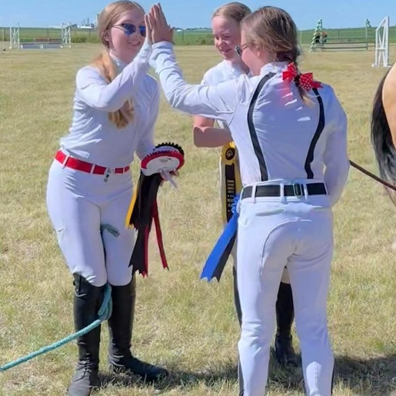

Entry Forms & Prize List: www.infinityequine.ca/events
General Inquiries and e-transfers: info@equinehaven.ca

 Spring Hunter/Jumper Series
Presented by Infinity Equestrian Sports Ltd & Equisport Riding and Services
Dear Riders, Trainers, and Equine Enthusiasts,
Welcome to our Spring Hunter/Jumper Series, where we celebrate the sport across two exciting weekends of competition and learning.
This series is designed to give riders the opportunity to gain experience in both hunter and jumper disciplines within a supportive and educational environment. Each weekend highlights a different focus: the elegance and precision of the hunter ring, and the energy and challenge of the jumper ring.
Whether you are polishing your hunter rounds or testing your skills over jumper courses, these weekends are about building confidence, developing feel, and enjoying time in the saddle.
Our Hunter Show weekend highlights style, rhythm, and partnership between horse and rider, while the Jumper Show weekend brings the excitement of navigating courses with accuracy, pace, and precision.
This series is proudly hosted by Infinity Equestrian Sports Ltd (Infinity Equine) and Equisport Riding and Services, organizations dedicated to fostering growth, confidence, and excellence in the equestrian community. From first-time competitors to seasoned riders, we hope these weekends provide a welcoming space to learn, compete, and connect with fellow horse enthusiasts.
A heartfelt thank you goes to our sponsors, volunteers, officials, and supporters — your dedication makes these events possible.
We wish every horse-and-rider team a safe, successful, and enjoyable experience throughout the series.
Saddle up, ride your best, and enjoy the journey.
Warm regards,
The Team at Infinity Equine



Old As Dirt Classes
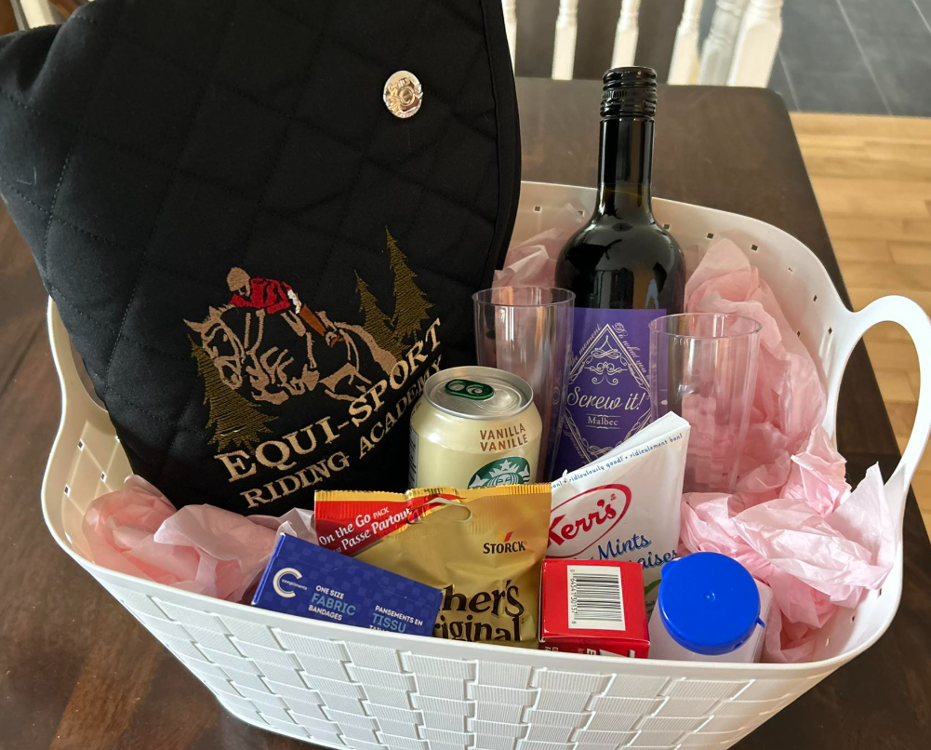
Old as Dirt Class
Our Old as Dirt Class is designed especially for adult riders (18+) who still love to ride, compete, and challenge themselves in the ring. This class gives adult amateurs, parents, and late starters a chance to enjoy the show atmosphere without competing against their kids.
Three height options will be offered to accommodate riders at different stages of their journey. For the Hunter Show, heights include X-Rails, 18", and 2’ will be offered for this division. For the Jumper Show, heights include X-Rails, 0.45m, and 0.60m will be offered.
Whether you’re getting back in the saddle, developing your riding skills, or simply looking to have some fun in the ring, this class is all about support, encouragement, and celebrating adult riders in our sport.
This class is proudly sponsored by Equisport Riding and Services, and the winner will take home a gift basket prize.
Because riding is for every age — even those of us who are “old as dirt.”

JUMPER DIVISIONS & CLASSES
Class # | Division | Height | Description | Fee
1 | X-rails | X-rails | Clear Round | $25
2 | X-rails | X-rails | MTC Jumper Round | $35
3 | X-rails | X-rails | MTC Jumper Round | $35
4 | 0.6m | 0.6m | Clear Round | $25
5 | 0.6m | 0.6m | MTC Jumper Round | $35
6 | 0.6m | 0.6m | Speed | $35
7 | 0.7m | 0.7m | Clear Round | $25
8 | 0.7m | 0.7m | Speed | $35
9 | 0.7m | 0.7m | Jumper, Jump Off | $35
10 | 0.8m | 0.8m | Clear Round | $25
11 | 0.8m | 0.8m | Speed | $35
12 | 0.8m | 0.8m | Jumper, Jump Off | $35
13 | 0.9m | 0.9m | Clear Round | $25
14 | 0.9m | 0.9m | Speed | $35
15 | 0.9m | 0.9m | Jumper, Jump Off | $35
16a | Old As Dirt | X-Rails | MTC Jumper Round | $35
16b | Old As Dirt | 0.45m | MTC Jumper Round | $35
16c | Old As Dirt | 0.6m | MTC Jumper Round | $35

HUNTER DIVISIONS & CLASSES
Class # | Division | Height | Description | Fee
20 | Poles | Poles | Hunter Over Fences | $25
21 | Poles | Poles | Handy Hunter | $25
22 | Poles | Poles | Equitation Over Fences | $25
23 | X-rails | X-rails | Hunter Over Fences | $35
24 | X-rails | X-rails | Handy Hunter | $35
25 | X-rails | X-rails | Equitation Over Fences | $35
26 | 18” | 18” | Hunter Over Fences | $35
27 | 18” | 18” | Handy Hunter | $35
28 | 18” | 18” | Equitation Over Fences | $35
29 | 2’ | 2’ | Hunter Over Fences | $35
30 | 2’ | 2’ | Handy Hunter | $35
31 | 2’ | 2’ | Equitation Over Fences | $35
32 | 2’3” | 2’3” | Hunter Over Fences | $35
33 | 2’3” | 2’3” | Handy Hunter | $35
34 | 2’3” | 2’3” | Equitation Over Fences | $35
35 | 2’6” | 2’6” | Hunter Over Fences | $35
36 | 2’6” | 2’6” | Handy Hunter | $35
37 | 2’6” | 2’6” | Equitation Over Fences | $35
38a | Old As Dirt | X-Rails | Equitation Over Fences | $35
38b | Old As Dirt | 18” | Equitation Over Fences | $35
38c | Old As Dirt | 2ft | Equitation Over Fences | $35

Hunter/Jumper Show Details
ADMINISTRATION: Infinity Equine and Equisport Riding and Services reserve the right to cancel or combine any given classes that do not have the minimum 3 entries required. All exhibitors in cancelled classes will be notified by either email or telephone (if number is provided on entry form) and any entry fees refunded. No advanced notification will be given for combined classes.
ADMINISTRATION: Infinity Equine shows are open to all riders; however, we reserved the right to refuse any entry, to make changes to the arena classes run in, judges, or class order to best facilitate the running of the show. We also reserve the right to start each division up to 30 minutes earlier than the posted schedule if the number of entries permit.
SAFETY: The judge reserves the right to eliminate any horse/rider combination that exhibits excessive speed, abuse to the horse, unsafe or unsportsmanlike behavior, or lack of control, with no refund of fees.
ENTRY FORMS: Please fill out one entry form per horse/rider combination. Entry form can be found at www.infinityequine.ca/events
CANCELLATION POLICY: Cancellation before closing date of entries will receive a full refund. Cancellation after closing date but before the start of the horse show will receive a refund less any stall fees and a $50 administration fees. Cancellation after the start of the horse show, with proof of Vet Certificate, class fees for remaining classes will be refunded. Closing date for entries is Oct 20th, 2025.
ADD/SCRATCHES: There will be no charge for adds/scratches the day before classes for horses already entered. Same day adds are acceptable as long as the class has not already started. Classes scratched the day before will be refunded; however, same day scratches are non-refundable.
LATE FEES: Entries received after the closing date for the show will pay a post entry fee of $20. Horses showing in a class without being entered will pay DOUBLE the class fee.
MEMBERSHIPS: All competitors must hold an Alberta Equestrian Federation membership. If out of province, proof of provincial membership must be available. Any competitor that does not have a valid AEF membership after the start of the competition will be eliminated from the competition without a refund.
OPEN SCHOOLING/WARM-UP: Schooling will be available on Saturday May 2nd for our Jumper show and Saturday May 9th, for our Hunter show and will be blocked times. Please have your coach schedule a time for schooling with the show office. Schooling is $35 per horse and rider combination.
AEF RULES: Every class offered herein is covered by the rules and specifications of the current rules of the AEF and will be judged in accordance with the AEF rule book as disclosed on their website. The management reserves the right to decide any point not covered in the rules and to correct any error or make any alterations that may be necessary in the prize list. AEF rules and regulations will be followed.
ABUSE: Abuse of the horse is strictly forbidden. Abuse includes, but is not restricted to, excessive use of spurs, abuse of the whip (see EC Article G115.2) and brutal use of the reins during halts or rein backs, repeated tugs on the horse’s mouth. Excessive use of the whip: the whip cannot be used to vent a rider’s temper. Such use is always excessive. The whip is not to be used after elimination or after a horse has jumped the last fence on a course. The whip is never to be used overhand, (e.g. a whip in the right hand being used on the left flank). The use of a whip on a horse’s head is always excessive use. A horse should never be hit more than three times for any one incident. If a horse’s skin is broken, it is considered excessive use of the whip. A person identified as misusing or excessively using the whip will be disqualified at the discretion of the judge.
ACCOMODATIONS: Overnight stalls are available for the weekend for those wishing to stay over Saturday night for $60. Bedding is included. Priority will be assigned in the order entry forms are received. Please see the entry form for pricing.
HAUL INS: Trailering in is welcome for no additional fee; however, all horses and riders must be entered in the show and be assigned a number. Space for RVs will be made available on request.
PROTECTIVE HEADGEAR: All competitors must wear proper fitting and approve headgear, with safety harness correctly secured, at all times while mounted on the event grounds. Helmets must meet ASTM standards and display the SEI seal. The British standard BSI is also acceptable. Any rider found violating this rule will be prohibited from further riding on event grounds until a helmet is properly in place.
PARAMEDIC FEE: The paramedic fee covers the cost of the medical aid on site. The fee does not cover personal expenses incurred by the injured party in the event of an injury or transportation by ambulance.
BIOSECURITY: We strongly recommend that all horses be vaccinated with 3-way, per AEF guidelines, prior to the show. Prior to trailering to the show please take and record your horses’ temperature when it is at rest and NOT immediately following exercise or trailering. Your horses’ temperature should be below 39℃ or 102℉. If your horse is showing signs of sickness or fever, please contact the show office immediately.
RIBBONS – Champion and Reserve Champion will be for all divisions. Ribbons will be awarded in all classes, including the hobby horse classes, through 6th place.
DOGS: No dogs are permitted on the event grounds.
SEATING: Please bring your own chairs for viewing the ring.
LUNGING: For safety reasons lunging is not permitted in the indoor arena on show days.
PARKING: Please see diagram below.

