2025
Heidi Pratt
Infinity Equine
7/1/2025
Infinity Equine Hobby Horse Club Rulebook

Table of Contents
📘 Official Rulebook 1
1.0 Equipment & Attire 1
1.1 1
1.2 Rider Attire: 1
2.0 General Etiquette 1
2.1. Sportsmanship and Respect 1
2.2 Respect for Club Organizers, Judges and Volunteers 1
2.3 Arena Courtesy 1
2.4 Attire and Presentation 1
2.5 Hobby Horse Handling 1
2.6 Parental & Spectator Conduct 1
2.7 Inclusivity and Conduct 1
2.8 Clean-Up and Responsibility 1
3.0 Event Format and Procedures 1
3.1 Day Camp Program: Learning Through Hobby Horsing 1
3.2 Competition Format 1
4.0 Jumping Competitions 1
4.1 Ring Sizes for Jumper Classes 1
Tips: 1
4.2 Age Divisions & Fence Heights 1
4.3 Speed Classes 1
4.3.a Speed Classes Judging Criteria 1
4.4 Equitation Over Fences Classes 1
4.4a Equitation Classes Judging Criteria 1
4.5 Puissance (High Jump) 1
5.0 Non-Jumping Competitions 1
5.1 Dressage Ring Sizes 1
5.2 Hobby Horse Dressage Age Divisions & Expected Movements 1
5.2.a Notes for Each Level 1
5.3 Judging Criteria for Hobby Horse Dressage Movements 1
5.3.a Accuracy of Movements 1
5.3.b Rhythm and Tempo 1
5.3.c Impulsion and Energy 1
5.3.d Harmony and Connection 1
5.3.e Balance and Position 1
5.3.f Creativity and Expression 1
5.3.g Overall Presentation 1
5.4 Dressage Movements & Judging Criteria for a Perfect Score 2
5.4a Walk 2
5.4.b Trot 2
5.4.c Canter 2
5.4.d Halt 2
5.4.e Rein Back 2
5.4.f Circles (Large and Medium) 2
5.4.g Serpentines and Figure-Eights 2
5.4.h Changes of Direction 2
5.4.i Shoulder-In 2
5.4.j Leg Yield 2
5.4.k Flying Lead Change (Simulated) 2
5.4.l Extended and Collected Trot (Simulated) 2
5.5 Key Tips for a Perfect Score 2
5.6 Example Hobby Horse Dressage Tests 2
5.6.a Introductory Division (Ages 6-8) - Basic Walk and Halt 2
5.6.b Beginner Division (Ages 9-11) - Walk and Trot Transitions 2
5.6.c Intermediate Division (Ages 12-14) - Walk, Trot, and Basic Lateral Movement 2
5.6.d Advanced Division (Ages 15-16) - Walk, Trot, Canter, and Lateral Movements 2
6.0 Volunteers 2
6.1 Volunteer roles 2

Infinity Equine Hobby Horse Club Rulebook

📘 Official Rulebook
The Infinity Equine Hobby Horse Jumping Club Rulebook is based on a combination of international best practices from leading hobby horsing organizations. We’ve drawn inspiration from the British Hobby Horse Association, the Finnish Hobbyhorse Federation, and event guidelines used in the USA, Germany, and Canada. These standards ensure fair, safe, and inclusive competition for riders of all ages and experience levels while maintaining the fun and creativity that make hobby horsing so unique.
This document outlines the official rules and structure of the Infinity Equine Hobby Horse Jumping Club.
This rulebook is subject to updates as the club grows. For questions, contact us at infinityequineab@gmail.com

1.0 Equipment & Attire
1.1 Hobby Horse Requirements:
1.) Must have a soft head attached to a stick.
2.) Head should be at least 25 cm (10 inches) long.
3.) Stick must extend behind the rider while "mounted."

1.2 Rider Attire:
1.) Comfortable, athletic clothing or traditional equestrian-inspired outfits.
2.) Closed-toe athletic shoes required (no sandals or bare feet).
3.) Helmets are optional but encouraged for younger riders.

2.0 General Etiquette
To ensure a safe, inclusive, and enjoyable experience for all participants, spectators, and organizers, the following etiquette guidelines must be followed at all hobby horse events:

2.1. Sportsmanship and Respect
- Always demonstrate good sportsmanship—win or lose, congratulate others and show appreciation for judges, organizers, and volunteers.
- Treat all competitors, regardless of age or skill level, with kindness and encouragement.
- Derogatory language, mocking others’ horses or attire, and negative comments about performances are strictly prohibited.

2.2 Respect for Club Organizers, Judges and Volunteers
- Show courtesy toward judges, club organizers, volunteers and event staff. Do not question their decisions during events or while the show is underway.
- If clarification is required, approach the designated club organizers respectfully after the class has concluded.
- Cheering and clapping are encouraged, but excessive noise that disrupts a performance is discouraged.

2.3 Arena Courtesy
- Do not enter the ring until your class or number has been called.
- Give space to other competitors in warm-up and competition areas. Passing should be done on the outside unless otherwise directed.
- Keep the flow of traffic moving and avoid blocking entry gates, course paths, or trail elements.

2.4 Attire and Presentation
- Hobby Horse Riders should be neat and clean in appearance, with hair tidy and hobby horses well-maintained.
- Costumes are welcome in themed or freestyle classes but must remain safe, appropriate, and respectful.
- No part of an outfit should restrict movement or visibility or pose a tripping hazard to the rider or others.

2.5 Hobby Horse Handling
- Hobby horses should be carried respectfully when not in use—dragging or tossing them is considered poor form.
- Treat your hobby horse as you would a real equine partner. This includes “patting out” after a round and not using aggressive gestures.

2.6 Parental & Spectator Conduct
- Parents and spectators must remain in designated spectator areas, outside competition and warm-up rings at all times.
- Coaching from the sidelines is discouraged once a class begins, especially in judged events.
- Applaud all riders equally and refrain from loud or disruptive behavior.

2.7 Inclusivity and Conduct
Infinity Equine is committed to maintaining a welcoming and inclusive environment where all riders feel safe and valued. Bullying of any kind—whether verbal, physical, social, or online—is not tolerated at any Infinity Equine event, including Hobby Horse competitions.
Examples of bullying include:
- Teasing or mocking someone’s horse, outfit, performance, or ability
- Excluding others from group activities or warm-ups
- Spreading rumors or making hurtful comments
- Intimidation, threats, or any behavior meant to cause harm
All participants, spectators, and volunteers are expected to uphold the spirit of our Anti-Bullying Policy. Incidents should be reported immediately to event staff or organizers. We take all reports seriously and will respond promptly with appropriate action, which may include removal from the event or further disciplinary measures.
We believe everyone deserves the opportunity to enjoy horses—real or hobby—in a safe and uplifting environment.
Hobby horse events are inclusive of all genders, backgrounds, and ability levels. Discrimination or bullying of any kind will result in removal from the event. If a conflict arises, bring it to the attention of club or show staff or an organizer rather than engaging with other participants directly.

2.8 Clean-Up and Responsibility
- Club members are expected to clean up after themselves and dispose of garbage properly.
- Lost-and-found items should be turned into club organizers or the show office.
- Be mindful of the facility and leave it in better condition than you found it.

3.0 Event Format and Procedures
Our Hobby Horse Days are designed to offer both learning and fun for riders of all levels. The day begins with an engaging Day Camp where participants build essential skills and knowledge across all aspects of hobby horsing. In the afternoon, riders put their new skills to the test in friendly competitions that celebrate creativity, sportsmanship, and progress.

3.1 Day Camp Program: Learning Through Hobby Horsing
The morning portion of Hobby Horse Days is dedicated to our Day Camp Program, a fun and educational experience designed to introduce riders to the full spectrum of hobby horsing. Whether you are brand new to the sport or looking to deepen your knowledge, this camp-style format offers hands-on learning in a welcoming and inclusive environment.
Participants will rotate through a series of interactive stations covering a wide range of topics, including:
Horse Care & Tack Basics: Learn how to "tack up" your hobby horse properly, explore different types of bridles, and accessories, and understand how they relate to real horse equipment.
Grooming & Stable Management: Practice grooming your hobby horse, maintaining equipment, and caring for your “mount” as if it were a real equine partner.
Rules & Ring Etiquette: Gain confidence in how classes are run, how to behave in the ring, and what judges are looking for in different disciplines.
Introduction to Disciplines: Try out movements and patterns from various hobby horse classes such as dressage, jumping, flat, and trail.
Course Walking & Strategy: Learn how to walk a jump or obstacle course, plan your approach, and ride a smart, clean round.
Creative Expression: Explore freestyle performance, costume design, or hobby horse customization to help express your personal style in the sport.
The focus is on building foundational knowledge, encouraging creativity, and fostering good sportsmanship. Campers will develop skills not just as riders, but as well-rounded horse people—even if their horses are handmade!
Campers should come prepared for active participation, bring their hobby horse, and wear appropriate footwear. All materials and guidance will be provided by our friendly instructors and volunteers.
The Day Camp lays the groundwork for the afternoon’s competition classes, giving riders the confidence and tools they need to shine in the ring.

3.2 Competition Format
Hobby Horse competitions are structured to ensure fairness, fun, and a positive experience for riders of all ages and abilities. Events may be run as single-day shows or multi-day competitions, depending on the scale. Each show will follow a pre-posted schedule, with class times, division breakdowns, and course maps made available ahead of time whenever possible.
Riders are grouped into appropriate age or skill-based divisions to promote fair competition. Depending on the class type, competitors may ride individually (e.g., Dressage, Equitation, Jumping), in pairs or teams (e.g., Relay), or as part of a group (e.g., Flat classes). Riders must be present and ready when their class is called. Classes will not be re-run for late arrivals unless due to a show organizer’s error or approved delay.
Each class is judged based on its individual criteria, and scores or placings will be announced at the conclusion of the class. Ribbons are typically awarded to the top six riders in each class, though this may vary depending on class size.
Warm-up areas will be provided when space allows, but riders are expected to use them respectfully and follow posted warm-up etiquette. There may also be a designated holding or marshalling area where riders will wait before entering the ring.
At multi-day events or show series, points may be tracked for overall division placings or series champions. Riders must be aware of entry requirements, class restrictions, and tack or attire rules specific to each show.
All competitors are expected to check in upon arrival and confirm their entries with the show office or registration desk. Any changes or scratches must be communicated in a timely manner. Good communication helps the show run smoothly and ensures all riders have the best experience possible.
As the club continues to grow, we hope to introduce year-end awards for each division, based on cumulative points earned throughout the season. These awards will recognize consistency, dedication, and progress across multiple events and will be announced in advance once implemented.

4.0 Jumping Competitions
Hobby Horse shows feature a variety of classes designed to challenge riders' skills, creativity, and horsemanship in a fun and supportive environment. Whether you’re just starting out or an experienced competitor, there’s something for everyone. Classes may be judged on speed, style, accuracy, or artistic expression depending on the discipline. Riders are encouraged to try multiple types of classes to experience the full range of what hobby horsing has to offer.

4.1 Ring Sizes for Jumper Classes
Jumper classes require a ring large enough to safely accommodate a variety of jump elements, turning lines, and flowing courses. While recommended dimensions are provided to help guide course planning, individual event venues are encouraged to select ring sizes that best suit their available space and safety considerations. Whether indoors or outdoors, the priority is to ensure riders have enough room to perform confidently, with safe distances between fences and clear entry and exit points.
  - Minimum Size: 10m x 20m (33ft x 66ft)
Ideal for small classes, younger riders, or indoor venues. Allows for a basic course of 4–5 jumps with turns and diagonals.
  - Standard Size: 15m x 25m (50ft x 82ft)
Best for most divisions, including Intermediate and Advanced riders. Provides space for full courses with 6–8 jumps, including bending lines and combinations.
  - Large/Competition Size: 20m x 30m (66ft x 98ft)
Suitable for larger venues or championship-style rounds. Allows for wider turns, oxers, and flowing jumper-style courses.

Tips:
- Ensure jump spacing allows for at least 3–4 strides between fences.
- Maintain clear entry/exit zones.
- Use soft poles or lightweight, safe materials.
- Include a designated warm-up area outside the ring if space permits.

4.2 Age Divisions & Fence Heights
Divisions may be adjusted based on the number of entries at each event.
Division Name | Age Range | Jump Height
Mini Stirrup | 6–8 | Crossrails (6"–12")
Short Stirrup | 9–11 | 12"–18"
Intermediate | 12–14 | 18"–24" (1'6"–2')
Senior | 15–16 | 24"–30" (2'–2'6")
Additional height or open divisions may be offered.

4.3 Speed Classes
Riders are timed as they navigate a course of jumps. Faults for knockdowns and refusals are added to determine the fastest, cleanest round.

4.3.a Speed Classes Judging Criteria
Speed classes are modeled after international hobby horse jumping formats, where riders navigate a course of 4–8 jumps as quickly and cleanly as possible. The timer starts when the rider crosses the starting line and stops upon completion of the last fence. Riders accumulate 4 faults for each knocked rail, with refusals and off-course rounds also penalized. Final placings are determined by the fastest time with the fewest faults. In the event of a tie, a jump-off or split placing may be used at the judge’s discretion.
  - Equitation Over Fences Classes
Judged on rider position, rhythm, and presentation rather than speed. Style points determine special awards.

4.4a Equitation Classes Judging Criteria
Posture & Position: Judges look for an upright, balanced posture with consistent alignment while navigating the course. Riders should demonstrate an athletic stance, proper use of arms and legs, and safe, confident approach to jumps.
Control & Rhythm: This score reflects the rider's ability to maintain a smooth, consistent pace while keeping their hobby horse properly balanced. Judges watch for steadiness in gaits, clean take-offs and landings, and overall rhythm through the course.
Creativity/Flair: Riders are encouraged to express their personality! Judges consider uniqueness in presentation, stylish or themed attire, and a confident, expressive performance that adds excitement without compromising safety or control.
Posture & Position | 4 points
Control & Rhythm | 3 points
Creativity/Flair | 3 points
Total | 10 points

4.5 Puissance (High Jump)
Judged solely on height cleared. Riders take turns attempting a single vertical fence that increases in height each round. Riders must jump cleanly (no knockdowns or refusals) to advance. The round continues until only one rider remains with a successful clear. In the case of a tie, the judges may elect to award a shared placing or an additional jump-off round.
Safety Note: For the safety of all participants, judges reserve the right to stop the Puissance competition at any height if they feel continuing would pose a risk to the hobby horsers competing. In such cases, the highest successful jumpers at that point will be declared tied winners. Rider safety and well-being are the top priority throughout the event.

5.0 Non-Jumping Competitions
Dressage and Freestyle classes are non jumping classes that showcase the harmony, precision, and creativity between rider and hobby horse. Dressage focuses on the execution of specific movements and patterns with accuracy and grace, while Freestyle allows riders to design their own routines set to music, expressing their unique style and personality. Both disciplines encourage skill development, artistic expression, and a deep connection with the hobby horse.

5.1 Dressage Ring Sizes
Dressage classes require a clear, well-marked area that allows riders to perform patterns with precision and flow. The ring size should reflect the level of complexity expected in each division, while ensuring all movements—circles, diagonals, and lateral work—can be executed smoothly and safely. While standard guidelines are provided, event venues may adjust dimensions to suit their available space, provided the movements in each test can still be performed accurately.

Recommended Ring Sizes by Division:
- Introductory (Ages 6–8):
8m x 12m (26ft x 40ft)
A small, manageable space for simple walk and halt patterns with letters A, C, E, B, and center X.
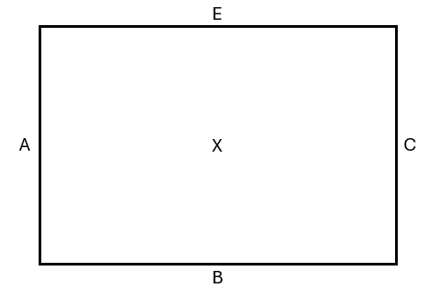
- Beginner (Ages 9–11) & Intermediate (Ages 12-14):
10m x 20m (33ft x 66ft)
Allows for basic trot work and large circles with letters A, C, E, B, H, M, F, K and center X scaled down for a smaller ring.
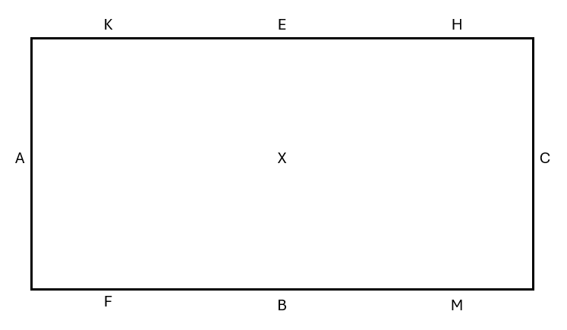
- Advanced (Ages 15–16):
15m x 30m (50ft x 98ft)
Suitable for more advanced figures, including canter work and lateral movements with letters A, C, E, B, H, M, F, K, R, S, V, P and center X.
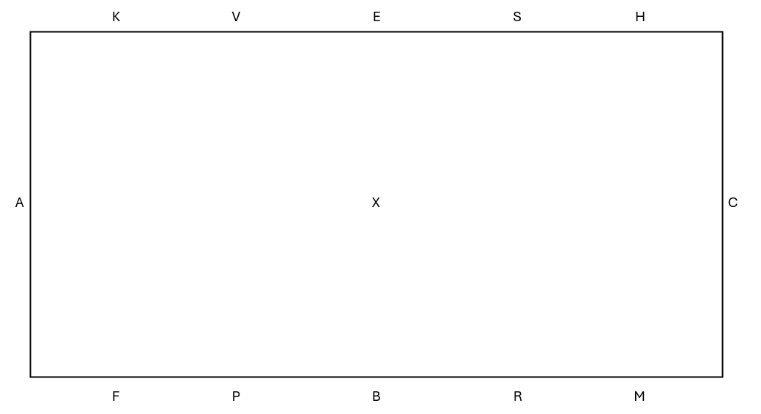

5.2 Hobby Horse Dressage Age Divisions & Expected Movements
Hobby Horse Dressage is structured to support the progressive development of riders across age groups. Each division introduces age-appropriate movements that encourage balance, coordination, and a growing understanding of dressage principles. As riders advance, tests become more complex, incorporating refined transitions, figures, and lateral work that reflect increased skill and control.
Division Name | Age Range | Expected Movements & Skills
Introductory | 6–8 | - Walk and trot on a loose rein  - Large circles (20m)  - Halt and rein back  - Simple changes of direction  - Basic transitions walk-trot-walk
Beginner | 9–11 | - Walk, trot, and introduction to canter  - Smaller circles (15m)  - Serpentines and figure-eights  - Transitions trot-canter-trot  - Halt, rein back with control
Intermediate | 12–14 | - Walk, trot, and canter with balance  - Medium circles (10-15m)  - Shoulder-in and leg yield introduction  - Flying lead changes (simulated)  - More precise transitions and lateral work
Advanced | 15–16 | - Consistent walk, trot, and canter with rhythm  - Complex figures like serpentines with changes of lead  - Shoulder-in, travers, and leg yield  - Extended trot and collected trot (simulated)  - More advanced transitions and expressive movements

5.2.a Notes for Each Level
1) Movements should be adapted to hobby horsing, focusing on rider’s ability to simulate the gaits and positions convincingly.
2) Transitions mean the rider visibly changes pace or gait smoothly.
3) Lateral movements (e.g., shoulder-in, leg yield) should be introduced gradually, with expectations rising with age and skill.
4) Emphasis is placed on balance, rhythm, and control appropriate to the rider’s development.

5.3 Judging Criteria for Hobby Horse Dressage Movements
Judges evaluate hobby horse dressage routines based on the following key movement criteria. Each movement is typically scored on a scale (e.g., 0–10), with deductions for inaccuracies, hesitation, or loss of rhythm.

5.3.a Accuracy of Movements
Riders should demonstrate precise execution of the prescribed figures and transitions, such as circles, serpentines, changes of direction, and lateral movements. Each movement should start and finish clearly within the designated arena markers.
5.3.b Rhythm and Tempo
The routine should maintain a consistent and appropriate rhythm throughout. Judges look for smooth, flowing movement without hesitation or rushing, reflecting a balanced pace similar to walk, trot, and canter.

5.3.c Impulsion and Energy
Movements should exhibit controlled energy and forward momentum. The rider should simulate impulsion by displaying lively, purposeful strides without rushing or dragging.

5.3.d Harmony and Connection
The rider and hobby horse should appear as a harmonious team. Judges look for confident, relaxed handling of the hobby horse, with fluid transitions and clear communication.

5.3.e Balance and Position
Riders should maintain an upright, balanced posture with proper alignment. Movements should be performed with grace and control, reflecting good equitation principles.
5.3.f Creativity and Expression
Particularly in freestyle classes, riders are encouraged to add musicality, choreography, and personal flair, enhancing the routine’s artistic impression.

5.3.g Overall Presentation
Cleanliness, turnout, and attention to detail in attire and hobby horse grooming may also be considered.

5.4 Dressage Movements & Judging Criteria for a Perfect Score

5.4a Walk
1) A clear, four-beat rhythm with even, relaxed steps.
2) Rider shows relaxed posture and consistent pace without rushing or dragging.
3) Movement appears natural and flowing.

5.4.b Trot
1) A two-beat gait with clear, regular rhythm and impulsion.
2) Rider maintains balance with minimal bounce and steady control.
3) Transitions into and out of trot are smooth and deliberate.

5.4.c Canter
1) A three-beat gait with clear rhythm and steady tempo.
2) Rider demonstrates balanced and coordinated movements with the hobby horse.
3) Transitions are precise and confident.

5.4.d Halt
1) A square, balanced stop with the rider upright and steady.
2) Rider remains still and balanced, without leaning forward or back.
3) The hobby horse “stands” squarely without movement.

5.4.e Rein Back
1) A controlled backward movement with clear steps.
2) Rider maintains straight alignment and even tempo.
3) Smooth start and stop without resistance.

5.4.f Circles (Large and Medium)
1) Circular shapes that are even and well-proportioned.
2) Rider maintains consistent pace and balanced posture throughout.
3) Smooth transitions into and out of the circle.

5.4.g Serpentines and Figure-Eights
1) Clear, flowing curves with balanced, rhythmic movements.
2) Rider maintains position on hobby horse through changes of direction.
3) Each loop is symmetrical and connected.

5.4.h Changes of Direction
1) Precise and clear shifts with minimal loss of rhythm.
2) Rider keeps straight alignment before and after the change.
3) Transitions are seamless.

5.4.i Shoulder-In
In a correct shoulder-in for hobby horsing, the rider uses their own body to represent the movement of the horse. “Turned in” means the rider’s upper body (representing the horse’s shoulders) is angled slightly inward, while their feet (representing the hind legs) stay aligned along the track or rail. The movement should show a slight bend through the whole body—not just a turned head—and be performed at a steady, forward-moving pace.
The outside leg remains on the track, while the inside leg steps forward and slightly across to simulate crossing tracks. The overall shape should show three clear lines of movement: one from the outside foot (hind leg), one from the inside crossing foot, and one from the angle of the shoulders. Jerky turns or overbending at the neck should be avoided.
1) The hobby horse is “turned” slightly inward on the forehand while moving forward on three tracks.
2) Rider demonstrates control of lateral position of hobby horse and forward impulsion.
3) Position is steady and rhythm consistent.

5.4.j Leg Yield
1) The hobby horse and rider move diagonally forward and sideways, crossing legs properly.
2) Rider maintains straight body alignment facing forward.
3) Movement is smooth and even.

Correct execution includes the following elements:
In a correct leg yield, the hobby horse’s legs (as demonstrated by the rider's footwork) should cross clearly and evenly. This means the inside leg steps across and in front of the outside leg as the rider moves forward and sideways at the same time. The crossing should be consistent, controlled, and show that the rider maintains forward momentum while moving diagonally. Uneven, hopping, or shuffling steps will score lower, as they show a lack of balance or rhythm.

5.4.k Flying Lead Change (Simulated)
In hobby horse dressage, a flying change represents a seamless transition from one canter lead to the opposite lead without breaking gait. Since the rider uses their own body to simulate the movement of the horse, the emphasis is on coordination, rhythm, and clarity of the change.
1) Rider demonstrates a clean, quick change of lead during the canter.
2) Position and timing are precise, maintaining rhythm and balance.
3) Transitions are smooth without hesitation.

Correct execution includes the following elements:
    - Clear Canter Rhythm Before the Change:
The rider should demonstrate a steady, balanced canter in the first lead for at least 3–4 strides before initiating the change. This establishes control and rhythm.
    - Straightness Through the Change:
The change should occur on a straight line or slight diagonal—not through a turn. The rider's body should remain upright and centered, avoiding leaning or twisting to one side.
    - Clean Leg Switch:
The rider must clearly switch the leading leg (the one stepping farther forward in the canter stride) to the opposite leg in mid-stride without breaking to trot or walk. The new lead should immediately pick up the correct canter rhythm on the new lead. The switch should be fluid, balanced, and without hesitation or hopping in place.
    - No Extra Steps or Pause:
There should be no trotting steps, skips, or pauses between the old and new leads. A clean flying change appears as one continuous motion.
    - Posture and Control:
The rider’s upper body should stay composed and show minimal effort—no flailing arms or exaggerated movements. The change should look purposeful and confident, not accidental or rushed.
    - Timing and Placement:
Ideally, flying changes should occur at a specific marker or point in the arena (e.g., the centerline or on a diagonal), showing that the rider is riding with intent and control.

5.4.l Extended and Collected Trot (Simulated)
The extended trot in hobby horsing is a powerful, forward-moving gait that demonstrates the rider’s ability to lengthen their stride while maintaining rhythm, balance, and control. It represents the moment in real dressage when a horse covers more ground by stretching its frame and extending its steps, rather than going faster.
In hobby horsing, this is achieved entirely through the rider’s leg movement, posture, and timing.
Extended trot shows lengthened strides with maintained impulsion and rhythm.
Collected trot shows shorter, elevated strides with engagement and balance.
Rider’s posture adjusts accordingly, showing control and expression.

Correct execution includes the following elements:
- Noticeable Lengthening of Stride:
The rider’s steps should visibly cover more ground than in a working trot. Each stride should extend farther forward, showing purposeful reach and suspension—not speed, but size and stretch.
- Steady Tempo, Not Faster:
The rhythm of the trot must stay consistent—it should not become a run, skip, or jog. Judges look for a clear two-beat trot pattern that remains the same in tempo, even as the strides grow longer.
- Upright, Composed Posture:
The rider’s upper body should remain tall, steady, and balanced, simulating the lifted and engaged frame of a horse in true extension. Arms (if holding the hobby horse reins) should be quiet and not pumping or flailing.
- Controlled Transitions:
The transition into and out of the extended trot should be smooth and deliberate, showing that the rider has control over their stride length. A good test might show 3–6 strides of clear extension before returning to working trot.
- Straightness and Forward Energy:
The extended trot should travel straight down the line (diagonal or long side) without wobbling or drifting. Energy should flow “forward and out,” not upward or chaotic.
Common Errors in Hobby Horse Extended Trot:
- Breaking into a run or skip
- Choppy, fast steps with no actual increase in stride length
- Loss of rhythm or balance
- Hunched posture or excessive arm motion
- Unclear transitions into and out of extension
A well-executed extended trot in hobby horsing gives the impression of controlled power, athleticism, and precision—big, bold steps without losing grace or harmony.

5.5 Key Tips for a Perfect Score
1) Consistency: Movements should flow smoothly with consistent rhythm and tempo.
2) Balance & Position: Rider’s posture must be upright and balanced throughout.
3) Accuracy: Each movement should start and finish clearly and precisely.
4) Harmony: The rider and hobby horse should look like a connected team.
5) Expression & Creativity: Especially in freestyle, personality and style add positive impact.

5.6 Example Hobby Horse Dressage Tests
Below are sample dressage tests designed for each age division, showcasing the typical movements and patterns riders can expect at their level. These tests provide a helpful guide to prepare and practice, helping riders build confidence and mastery step-by-step. While each test focuses on foundational skills, riders are encouraged to express their own style and creativity within the guidelines.

5.6.a Introductory Division (Ages 6-8) - Basic Walk and Halt
Enter at the walk
Proceed straight down the centerline
Halt in the middle of the ring (4 seconds)
Salute and continue walking to the end of the arena
Turn and walk back on the opposite side of the centerline
Halt at the center, salute, and exit the ring at a walk
Key Focus: Straightness, calm transitions, and basic control.

5.6.b Beginner Division (Ages 9-11) - Walk and Trot Transitions
Enter at the walk, proceed down the centerline
Halt and salute
Trot on a large circle (20m diameter) right
Walk on a diagonal line across the arena
Trot on a large circle left
Return to walk and halt at centerline, salute, exit
Key Focus: Smooth transitions, balance in trot, and basic circles.

5.6.c Intermediate Division (Ages 12-14) - Walk, Trot, and Basic Lateral Movement
Enter at walk, proceed centerline
Halt and salute
Trot on a circle right
Walk straight
Perform a simple shoulder-in on the track left for 10 meters
Trot on a circle left
Walk and halt at centerline, salute, exit
Key Focus: Introduction to lateral work, balanced trot, and precise halts.

5.6.d Advanced Division (Ages 15-16) - Walk, Trot, Canter, and Lateral Movements
Enter at walk, proceed centerline
Halt and salute
Trot circle right
Canter on a circle left
Perform a leg-yield from quarter line to track right
Trot diagonal line
Walk, halt at centerline, salute, exit
Key Focus: Controlled canter, lateral movements, smooth transitions, and accuracy.

6.0 Volunteers
Volunteers are the backbone of every event. From running competitions to teaching in the morning camp, every role plays a vital part in creating a successful, safe, and fun experience for all riders. We rely on the support of club members, parents, older riders, and community friends to help make each event a success.

6.1 Volunteer roles
Morning Camp Facilitators: Helping teach and guide riders through learning stations such as grooming, tack knowledge, basic dressage movements, ring etiquette, course walking, and creative sessions. Volunteers will be provided with materials and support to lead or assist with these stations.
Ring Crew: Setting up and adjusting jumps, poles, or trail elements between classes.
Gate Steward: Managing the in-gate, organizing rider order, and helping younger riders enter and exit the ring smoothly.
Warm-Up Supervisor: Ensuring safety and order in the warm-up area, offering guidance to riders when needed.
Score Runner or Tally Assistant: Assisting judges and organizers by collecting score sheets and updating class standings.
Awards and Registration: Helping with check-in, distributing numbers, and handing out ribbons and results.
Set-Up and Clean-Up Crew: Assisting with preparing the facility before the event and restoring it after the event concludes.
No experience is needed—just a positive attitude and a willingness to help. Volunteers will be given clear instructions and any materials or support needed for their assigned role. Whether you're able to help for a few hours or the entire day, your time and effort are incredibly appreciated.
If you're interested in volunteering, please sign up in advance when registering for the event or check in at the Volunteer Table on the day of the show. Your support keeps the club running and helps create a meaningful experience for every young rider.

