Spooktacular Jumper Classic
Oct 24th, 2026
Closing: Oct 17th, 2026

Show Manager: Heidi Pratt
Office: Helen Van Hemert
Judge: TBD
Paramedic/First Aid: Jessica McMorran
Course Designer: Jill Neufeld Fuselli / Heidi Pratt
$35 Office Fee

$15 Paramedic Fee

Ribbons to 6th with fun prizes
Goodies for the rider and cookies for the horse for all clear rounds
Prizes for Champion and Reserve
Hobby Horse & Hop Relay
Costume Class: Halloween Theme

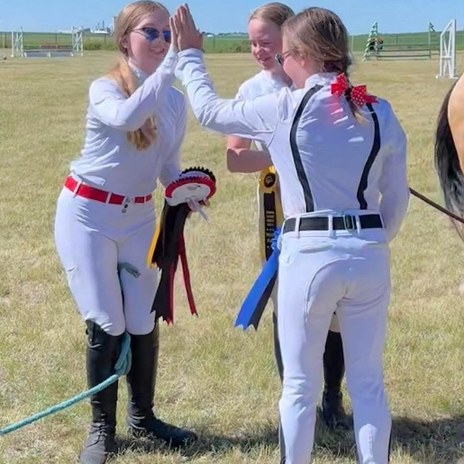

Entry Forms & Prize List: www.infinityequine.ca/events
General Inquiries: infinityequineab@gmail.com
 Spooktacular Jumper Classic
Presented by Infinity Equine & Equisport Riding and Services
Dear Riders, Trainers, and Equine Enthusiasts,
Welcome to the Spooktacular Jumper Classic — a Halloween-themed day of jumping, costumes, prizes, and fun as we celebrate another season of competition at Infinity Equine!
At Infinity, one of our biggest goals is to provide grassroots horse shows that are welcoming, affordable, and accessible. We believe the future of our sport starts with giving up-and-coming riders and horses opportunities to gain experience in a positive environment without the expense and pressure that can come with larger competitions.
Whether this is your very first horse show, you’re bringing along a green horse, you’re working toward moving up a division, or you simply want to get out and enjoy a fun day with your horse, we want there to be a place for you here.
And because it’s Halloween, this one is going to be a little different! 🎃
Along with our regular jumper divisions, the Spooktacular will feature a Costume Class, so start planning those costumes!
We’re also excited to bring our Hobby Horse & Hop Relay to the Spooktacular after it was originally planned for our cancelled Harvest Derby Classic. This fun relay combines a ridden portion with a hobby-horse portion and can be completed individually or as a team. Thanks to the generosity of Darcie Gwynne, there is even a trophy up for grabs! 🏆
Our shows are about more than ribbons. They’re about building confidence, developing horses and riders, learning how to compete, supporting one another, and helping grow the next generation of our sport. We want riders to be able to gain valuable show-ring experience while keeping showing fun and financially accessible.
A heartfelt thank you goes to our sponsors, volunteers, officials, competitors, families, and supporters. Affordable grassroots competitions only happen because of the people who give their time and support to make them possible.
From our youngest and newest competitors to our experienced horse-and-rider combinations, we hope everyone has a safe, successful, and ridiculously fun day.
Bring your costumes, bring your competitive spirit, and get ready for a Spooktacular day of jumping! 🎃👻🐴

Warm regards,
The Team at Infinity Equine



Thank You to Our Valued Sponsors
We believe that behind every great horse show is a community of passionate supporters—and our shows would not be possible without the incredible generosity of our sponsors.
Your support allows us to create an exciting, well-run event that celebrates horsemanship, sportsmanship, and community. From ribbons and prizes to class sponsorships and facility support, your contributions have a direct and meaningful impact on every horse and rider participating in this event.
We are proud to recognize and thank the following sponsors for their commitment to the sport and their belief in what we do:

🏅 Darcie Gwen – Hobby Horse & Hop Relay
🏅 Trace Embroidery – Prizes
🏅 EquiSport Riding and Services – Costume Class

Because of your generosity, riders of all levels are able to compete in a fun, safe, and professional environment that inspires confidence and camaraderie.
From all of us at Infinity Equine & Equisport Riding and Services—thank you.
We’re proud to have you as part of our community.

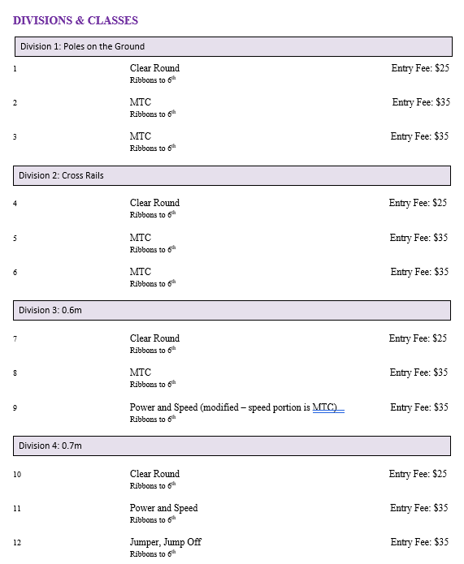

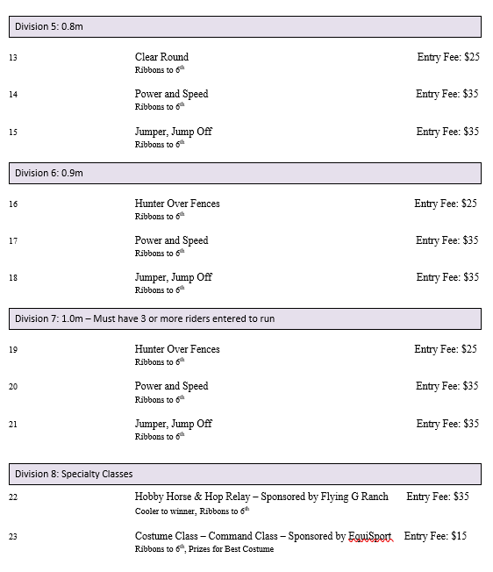

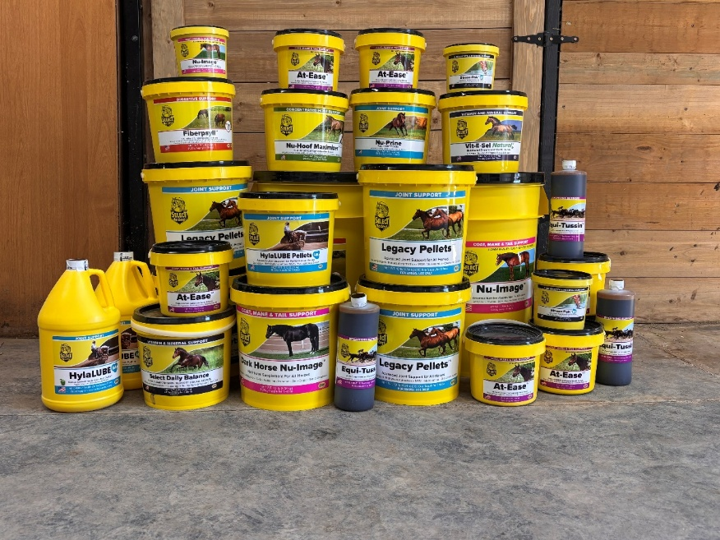

Give Your Horse the Best — Choose Select the Best!
Support your horse’s health, performance, and vitality with premium-quality supplements trusted by riders and trainers for over 25 years. From joint health to coat shine, Select the Best has a formula for every need. Because your horse deserves nothing less than the best.

Now available at Infinity Equine — your trusted equine supply partner.

HOBBY HORSE AND HOP RELAY
The first rider completes the designated mounted jumping course on their horse. Once they finish the mounted portion, they continue immediately to the Hobby Horse course — or they may tag a second rider to complete the Hobby Horse portion.
The clock runs continuously from the start of the mounted course until the Hobby Horse rider crosses the finish line.
Knocked rails add 4 seconds per rail to the team’s final time.
The Hobby Horse portion must be completed in full show clothing to keep the competition fair. No changing into running shoes or removing show gear before completing the Hobby Horse course.
🏆 Fastest combined time wins!
One horse. One Hobby Horse. One clock. How fast can you go? 🎃🐴

Show Details
ADMINISTRATION: Infinity Equine and Equisport Riding and Services reserve the right to cancel or combine any given classes that do not have the minimum 3 entries required. All exhibitors in cancelled classes will be notified by either email or telephone (if number is provided on entry form) and any entry fees refunded. No advanced notification will be given for combined classes.
ADMINISTRATION: Infinity Equine shows are open to all riders; however, we reserved the right to refuse any entry, to make changes to the arena classes run in, judges, or class order to best facilitate the running of the show. We also reserve the right to start each division up to 30 minutes earlier than the posted schedule if the number of entries permit.
SAFETY: The judge reserves the right to eliminate any horse/rider combination that exhibits excessive speed, abuse to the horse, unsafe or unsportsmanlike behavior, or lack of control, with no refund of fees.
ENTRY FORMS: Please fill out one entry form per horse/rider combination. Entry form can be found at www.infinityequine.ca/events
CANCELLATION POLICY: Cancellation before closing date of entries will receive a full refund. Cancellation after closing date but before the start of the horse show will receive a refund less any stall fees and a $50 administration fees. Cancellation after the start of the horse show, with proof of Vet Certificate, class fees for remaining classes will be refunded. Closing date for entries is Oct 20th, 2025.
ADD/SCRATCHES: There will be no charge for adds/scratches the day before classes for horses already entered. Same day adds are acceptable as long as the class has not already started. Classes scratched the day before will be refunded; however, same day scratches are non-refundable.
LATE FEES: Entries received after the closing date for the show will pay a post entry fee of $20. Horses showing in a class without being entered will pay DOUBLE the class fee.
MEMBERSHIPS: All competitors must hold an Alberta Equestrian Federation membership. If out of province, proof of provincial membership must be available. Any competitor that does not have a valid AEF membership after the start of the competition will be eliminated from the competition without a refund.
OPEN SCHOOLING/WARM-UP: Schooling will be available on Friday, September 19th and will be blocked times. Please have your coach schedule a time for schooling with the show office. Schooling is $35 per horse and rider combination.
AEF RULES: Every class offered herein is covered by the rules and specifications of the current rules of the AEF and will be judged in accordance with the AEF rule book as disclosed on their website. The management reserves the right to decide any point not covered in the rules and to correct any error or make any alterations that may be necessary in the prize list. AEF rules and regulations will be followed.
ABUSE: Abuse of the horse is strictly forbidden. Abuse includes, but is not restricted to, excessive use of spurs, abuse of the whip (see EC Article G115.2) and brutal use of the reins during halts or rein backs, repeated tugs on the horse’s mouth. Excessive use of the whip: the whip cannot be used to vent a rider’s temper. Such use is always excessive. The whip is not to be used after elimination or after a horse has jumped the last fence on a course. The whip is never to be used overhand, (e.g. a whip in the right hand being used on the left flank). The use of a whip on a horse’s head is always excessive use. A horse should never be hit more than three times for any one incident. If a horse’s skin is broken, it is considered excessive use of the whip. A person identified as misusing or excessively using the whip will be disqualified at the discretion of the judge.
ACCOMODATIONS: Overnight stalls are available for the weekend for those wishing to stay over Friday night for $60. Bedding is included. Priority will be assigned in the order entry forms are received. Please see the entry form for pricing.
HAUL INS: Trailering in is welcome for no additional fee; however, all horses and riders must be entered in the show and be assigned a number. Space for RVs will be made available on request.
TEMORARY STALL PANELS/ELECTRIC FENCING: Competitors are welcome to camp onsite with their horses for no additional fee. Horses must be kept in temporary panels, or electric fencing in the area provided. Owners/competitors must be camping onsite to facilitate proper care of their equine.
PROTECTIVE HEADGEAR: All competitors must wear proper fitting and approve headgear, with safety harness correctly secured, at all times while mounted on the event grounds. Helmets must meet ASTM standards and display the SEI seal. The British standard BSI is also acceptable. Any rider found violating this rule will be prohibited from further riding on event grounds until a helmet is properly in place.
PARAMEDIC FEE: The paramedic fee covers the cost of the medical aid on site. The fee does not cover personal expenses incurred by the injured party in the event of an injury or transportation by ambulance.
BIOSECURITY: We strongly recommend that all horses be vaccinated with 3-way, per AEF guidelines, prior to the show. Prior to trailering to the show please take and record your horses’ temperature when it is at rest and NOT immediately following exercise or trailering. Your horses’ temperature should be below 39℃ or 102℉. If your horse is showing signs of sickness or fever, please contact the show office immediately.
RIBBONS – Champion and Reserve Champion will be for all divisions. Ribbons will be awarded in all classes, including the hobby horse classes, through 6th place.
COSTUME CLASS – Will be run as a command class on the flat.
DOGS: No dogs are permitted on the event grounds.
SEATING: Please bring your own chairs for viewing the ring.
LUNGING: For safety reasons lunging is not permitted in the indoor arena on show days.
PARKING: Please see diagram below.

